**LEBANESE AMERICAN UNIVERSITY**

**USAID – HIGHER EDUCATION SCHOLARSHIP PROGRAM**

**HES - Volunteering Program Verification Form**

This form is to be used to document volunteering hours. If a student volunteers for multiple organizations, a separate form must be used for each organization. **This form must be turned in by the 28th of each month, the latest.**

I certify that the scholar Vanessa Saad completed a total of 5 hours of service at Life Sculptor.

The hours were completed hours as per the below:

Hours # 0 (date) _30/09 – 5/10_ (initials of supervisor) __A.K.___

Hours # 0 (date) _7/10 – 11/10_ (initials of supervisor) __A.K.___

Hours # 0 date) _14/10 – 18/10 (initials of supervisor) __A.K.___

Hours # 5 date) _21/10 -25/10 (initials of supervisor) __A.K.___

Brief description of the activities the scholar performed or participated in:

I conducted research on the topic of creative visualization and goal setting, focusing on several key subtopics. This included overcoming obstacles and limiting beliefs, where I explored techniques for reframing negative thoughts and overcoming self-doubt. I also examined creating action plans, introducing action planning and implementation intentions, and developing actionable steps to translate visualized goals into practice while offering tips for monitoring progress and adjusting plans as needed. Additionally, I provided an overview of visualization tools and resources, such as vision boards and visualization apps, along with recommendations for further reading, online courses, and guided visualization resources. Finally, I discussed the integration and practice of these techniques, emphasizing the importance of incorporating visualization and goal-setting into daily routines, maintaining motivation towards goals, and facilitating group discussions for brainstorming creative applications of visualization techniques.

Written feedback about the scholar’s performance:

Vanessa’s research into creative visualization and goal setting demonstrates her organizational and research abilities. She compiled actionable techniques and resources, reflecting her thorough understanding of the subject.

Please rate the overall performance of the scholar at your organization:

|  |  |  |  |
| --- | --- | --- | --- |
|  | Mastery (5) | Proficient (3) | Emerging (1) |
| **Problem solver** | X |  |  |
| **Engaged & Committed** | X |  |  |
| **Open-minded & multicultural** | X |  |  |

Signature

& stamp

__________________________

_

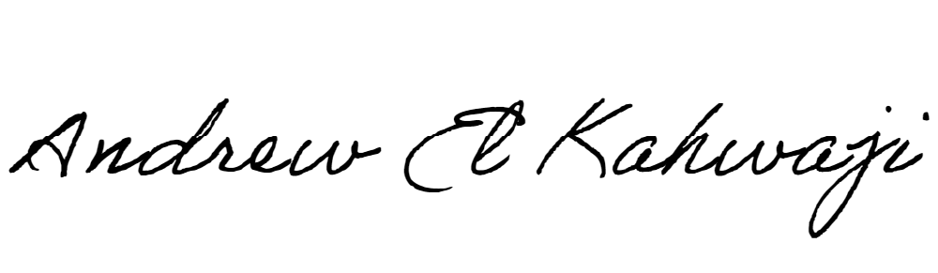

Printed Name _Andrew El Kahwaji_

Date __26/10/2024___

Email __andrew.lifesculptor.coo@gmail.com __

Phone __+961 71 914 378__

**LEBANESE AMERICAN UNIVERSITY**

**USAID – HIGHER EDUCATION SCHOLARSHIP PROGRAM**

